[Ionic] WalkingForTheBest - Report part 1

Description:
Phase 1: Developed a simple authentification feature using RESTful REQERS API.
Required package: Axios
The user is predefined in the da API/Login from REQERS API
The list with users is taken from REQERS API
FLOW:
- When the server starts the user is redirected to the Login page:
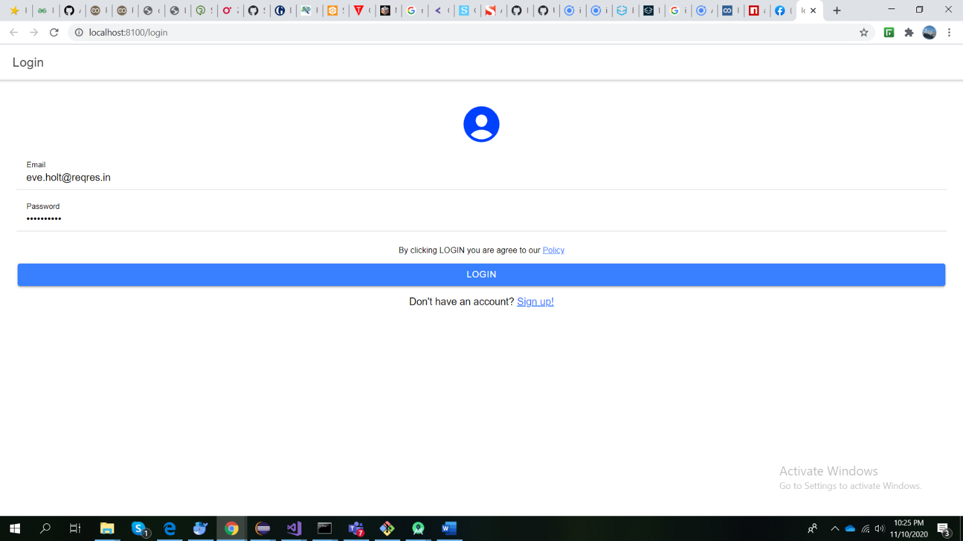

- After the login is done with success the user is redirected to a dashboard with the Team Members
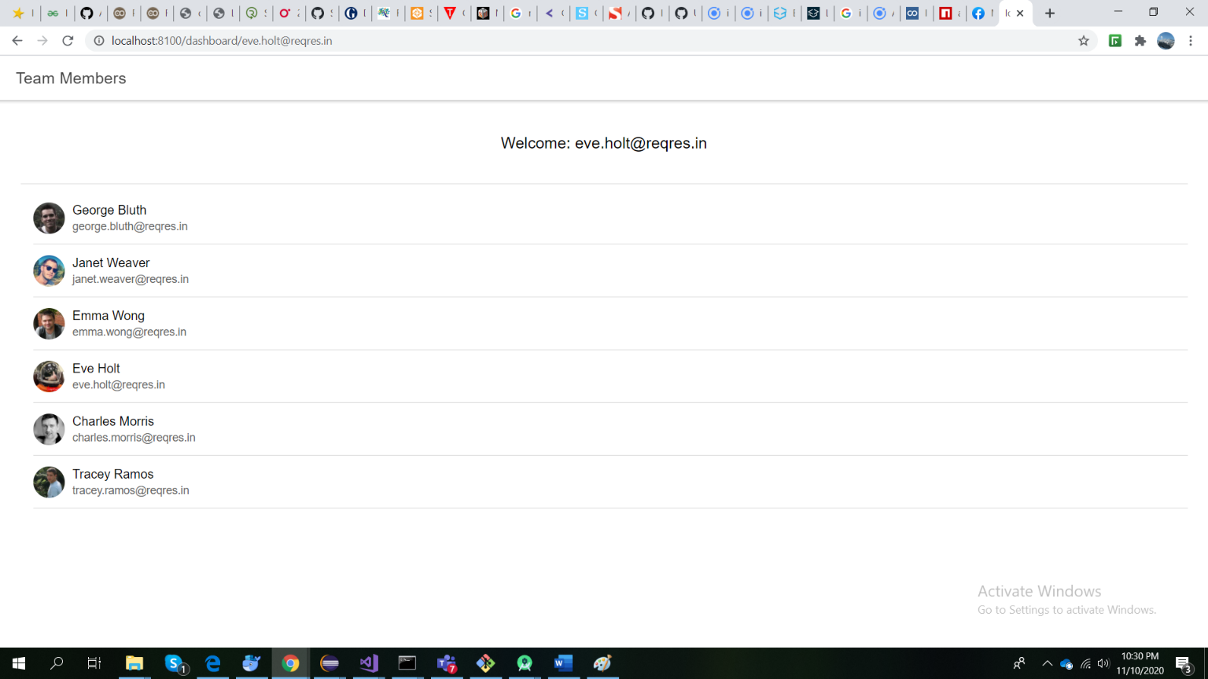

Obs:
- The login errors, like invalid password or e-mail are treated
- The sign up is not implemented yet

